Program:

A program is a set of instructions that performs operations on Data.

When the program is dealing with data, how it will organize the data in main memory that's where Data Structure is used .

Data Structure :

A Data Structure is a way of organizing and hold data in some manner so that it can be accessed,queries or update easily and quickly .

E.g :

1. Arrays
2. Trees
3. Linked List
4. Stack
5. Heaps
6. Stack
7. Queue
8. Hash Tables.

Basics Operations on Data Stucture :

1. Insert
2. Search
3. Delete
4. Access

Algorithms :

A process or set of steps to do a certain task.

E.g :

1. Searching Algo.
2. Sorting Algo.

Topic Wise Importance :

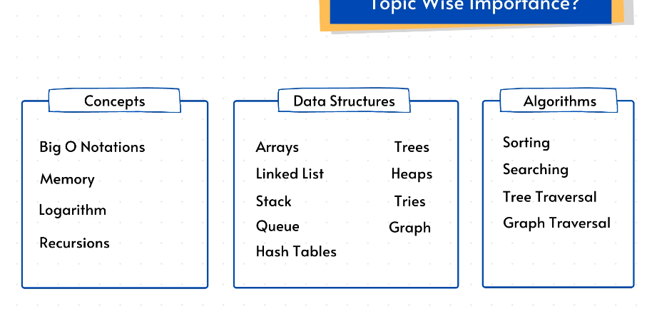

Complexity Analysis :

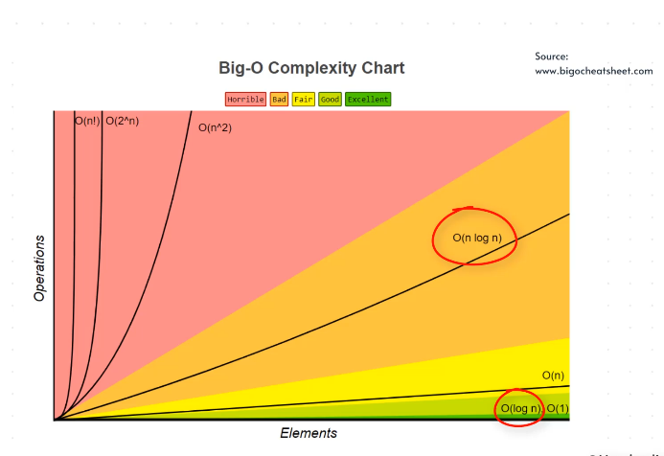

How to define good code ?

Ans :

Code which

1. Run Fast
2. Require Less Memory
3. Readable
4. Give Correct Output

BIG O Notation :

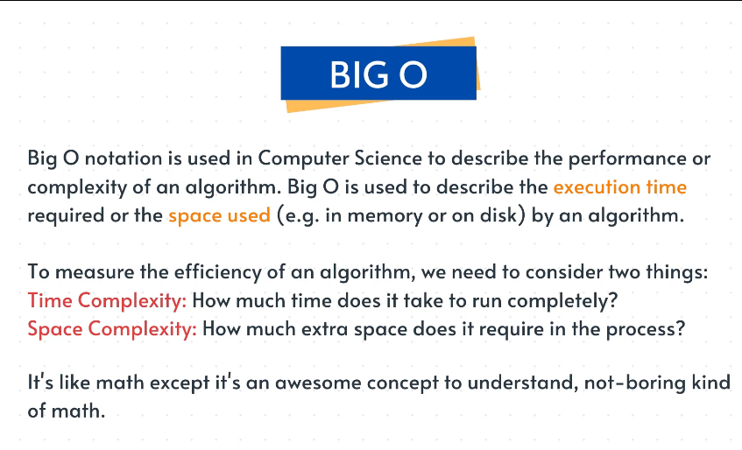

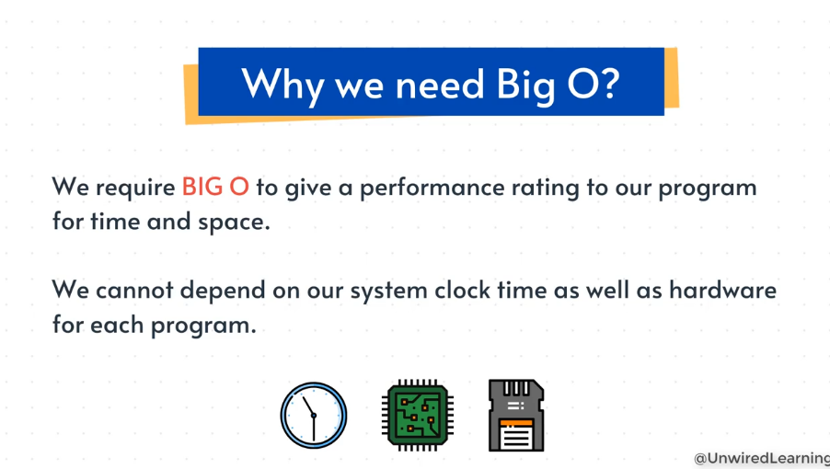

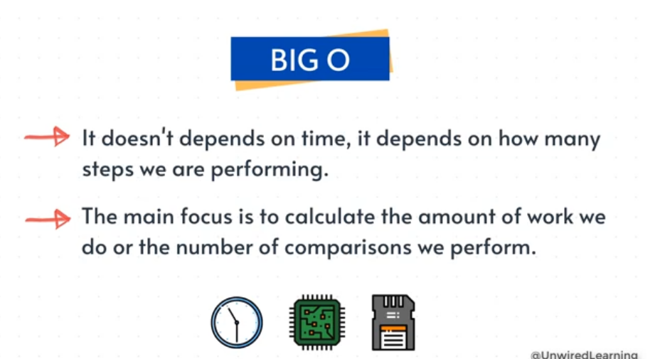

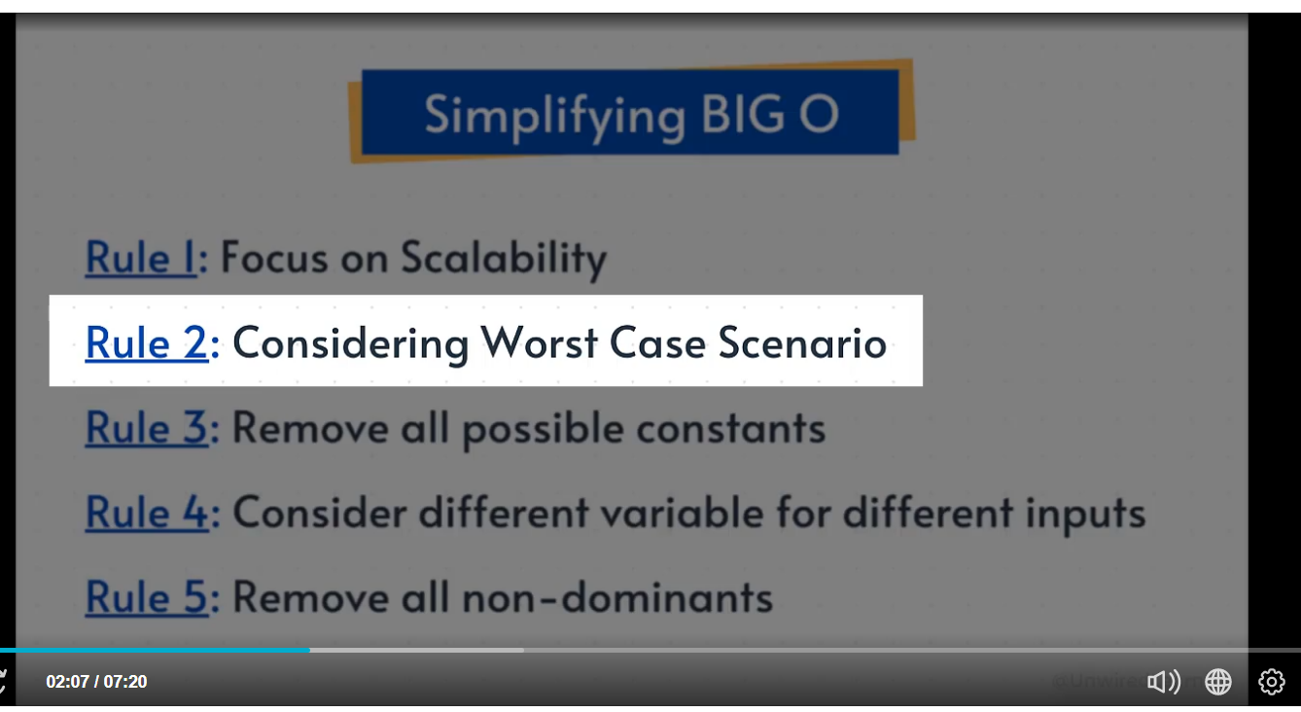

Space Complexity :

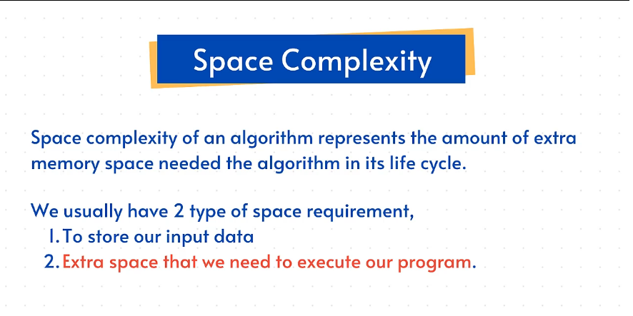

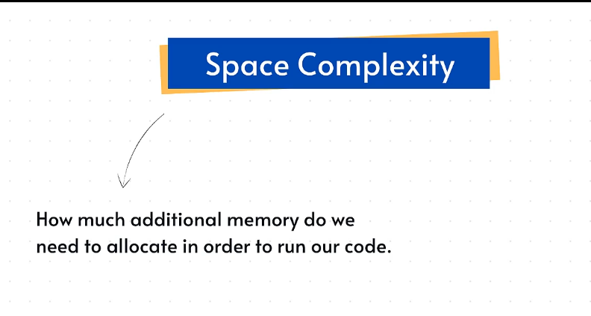

Summary :

